Alg 4 Summer Name: ___________________________

__________ _____________

WS Assessment

Target 2:

Imaginary and complex roots

**I can:**

* Perform operations on complex numbers (including conjugate)
* Solve quadratic equations with complex solutions
* Recognize when a polynomial would have complex roots

**Unit 7: Quadratic and Complex number**

* [**HSN.CN.A.1**](http://www.corestandards.org/Math/Content/HSN/CN/A/1/): Know there is a complex number *i* such that *i*2 = -1, and every complex number has the form *a + bi* with *a* and *b* real.
* [**HSN.CN.A.2**](http://www.corestandards.org/Math/Content/HSN/CN/A/2/): Use the relation *i*2 = -1 and the commutative, associative, and distributive properties to add, subtract, and multiply complex numbers.
* [**HSN.CN.C.7**](http://www.corestandards.org/Math/Content/HSN/CN/C/7/): Solve quadratic equations with real coefficients that have complex solutions.

Imaginary number

|  |  |  |  |  |  |  |  |  |
| --- | --- | --- | --- | --- | --- | --- | --- | --- |
| *i1* = | *i2* = | *i*3 = | *i4* = |  | *i17* | *i35* | *i98* | *i121* |
|  |  |  |  |  |  |  |  |  |
| *i5* | *i6* | *i7* | *i8* |  | *i164* | *i1640* | *i16402* | *i164027* |
|  |  |  |  |  |  |  |  |  |

Rewrite the following negative radical as imaginary number

$\sqrt{-1}=i$ $\sqrt{-9}=$ $\sqrt{-25}=$ $\sqrt{-6}=$ $\sqrt{-18}=$

Evaluate the following

3(2i) = (3i)(2i)= (4i)2 =

(2i)2(5i) = (3i)3 = (4i)4 =

*Complex number is the combination of real number and imaginary number.* It is written as a + bi

For example 5 + 3i Rewrite the following as complex number.

$-18-\sqrt{-25}=$ $\frac{2±\sqrt{-16}}{2}$ = $5+\sqrt{-6}=$ $\sqrt{-18}+1=$

Complex number are “binomials” of a sort, and are added, subtracted, and multiplied in a similar way. (Division is a bit different)

|  |  |
| --- | --- |
| **Add** | **Subtract** |
| (2 + 3i) + (1 – 6i) = | (2 + 3i) – (1 – 6i) = |
| (3 + 2i) + (6 – i) = | (3 + 2i) – (6 – i) = |
| (2.1 + .3i) + (2i – 1) = | (2.1 + .3i) – (2i – 1) = |

**Multiply**: Use the generic rectangle (the box)

(2 – i)(3 + i) (3 – 5i)(3 + 5i)

(4 – i)(2i + 6) (7 – 2i)(2i + 7)

Complex Conjugate and divide complex number

The Complex Conjugate of **a + bi** is **a – bi**, you just change the sign to its opposite.

Write the conjugate for the following

4 + i → 2 + 7i → 3 – 5i → a – bi →

**Divide** complex number. Steps: find conjugate of the denominator this conjugate to both top and bottom of the fraction, simplify the result if needed.

$$\frac{4-i}{6+2i}$$

$$\frac{2-i}{3+i}$$

$$\frac{-10-5i}{-6-6i}$$

$$(8+i)÷(2-i)$$

$$4÷(3-2i)$$

$$(2+5i)÷(i)$$

Complex plane

|  |  |
| --- | --- |
| The number - 4 + 4i is already graph on the complex plane. Base on this graph the following points. Show work  A = 5 – 5i  B = (1 - 2i) + (-5 + 4i)  C = (-1 + 2i) (2 - .5i) $$D=\frac{6+12i}{-1+3i}$$ |  |

Complex roots

1. How is complex root look like? Sketch the following

Real roots (x + 5)2 – 4 = 0 Complex roots (x + 5)2 + 4 = 0

Solve Solve

Solve the following quadratic equation by formula and squaring (complete the square). Remember, they all have solutions now, either real or complex

a. x2 – 10x + 29 = 0 b. x2 – 2x + 10 = 0

c. 2x2 + 5x + 4 = 0 d. x2 – 8x + 25 = 0

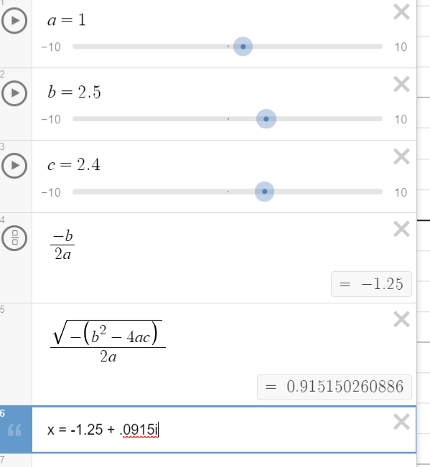

Solve a quadratic equation by formula, squaring and modified programming (stamp)

2x2 – 9x + 15 = 0

Rectangular a + bi vs Polar form r(cos $θ+isinθ)$

|  |  |
| --- | --- |
|  |  |

Convert from rectangular to polar form $r=\sqrt{a^{2}+b^{2}}$ $θ=\tan^{-1}\left(\frac{b}{a}\right)$

Write the complex number in polar form and graph it

-2 – 2i 2 + 2i -2 + 3i

Convert from polar to rectangular form a = r cos $θ$ b = r sin $θ$

Write the complex number in rectangular form and graph it

2(cos 60o + i sin 60o) 6(cos 30o + i sin 30o)

**Assessment Target 2   
I can…** perform basic operations on complex number and solve for complex roots

Write 2 complex numbers in from of a + bi (a $≠b>2$). Different from group

A = ____________ B = ______________

Now do the following

A + B A – B (A)(B) A $÷$ B

Graph the result in the complex plan (you choose the scale)

(A)(B) A $÷$ B

Convert your rectangular form in to polar from

A = B =

Write the quadratic equation in the form of 2x2 + ___x + _____ = 0 then solve for complex root with at formula and squaring. (If you do not have complex root, then change the equation until you get one). Show me the programing for stamp.